
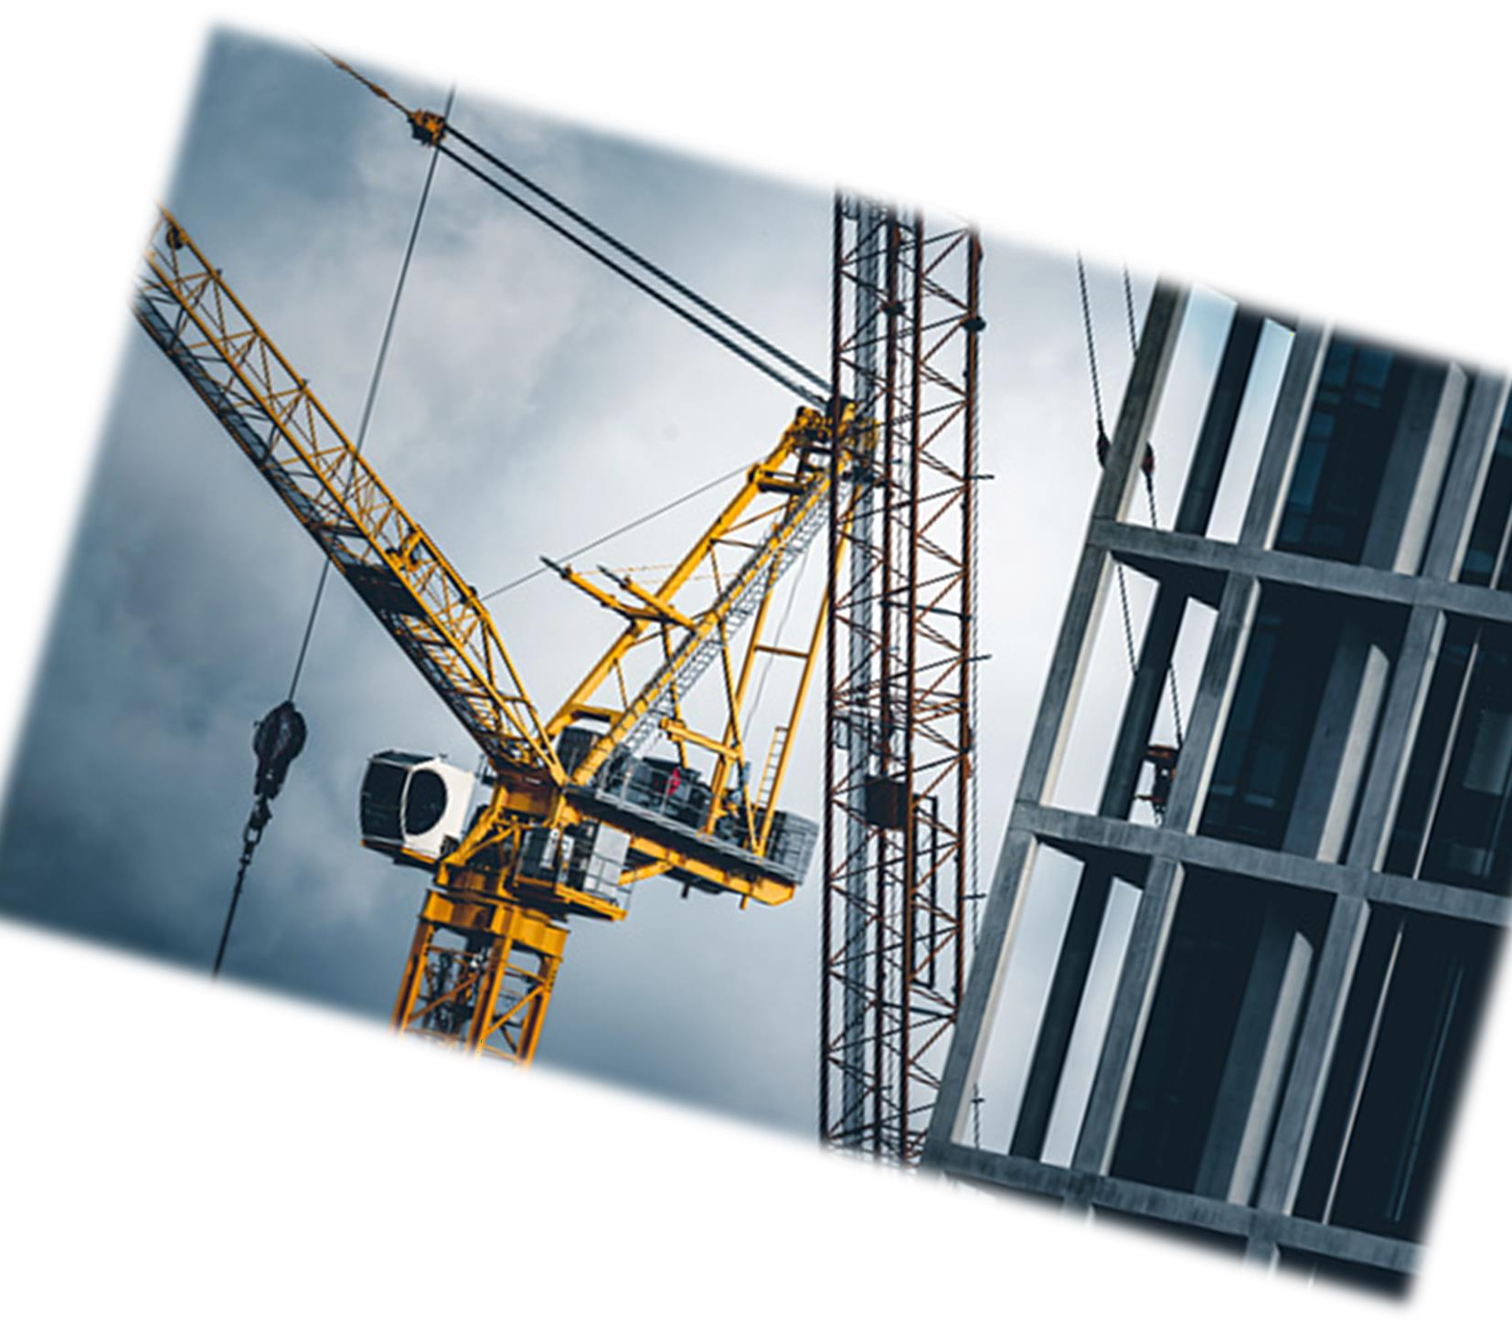
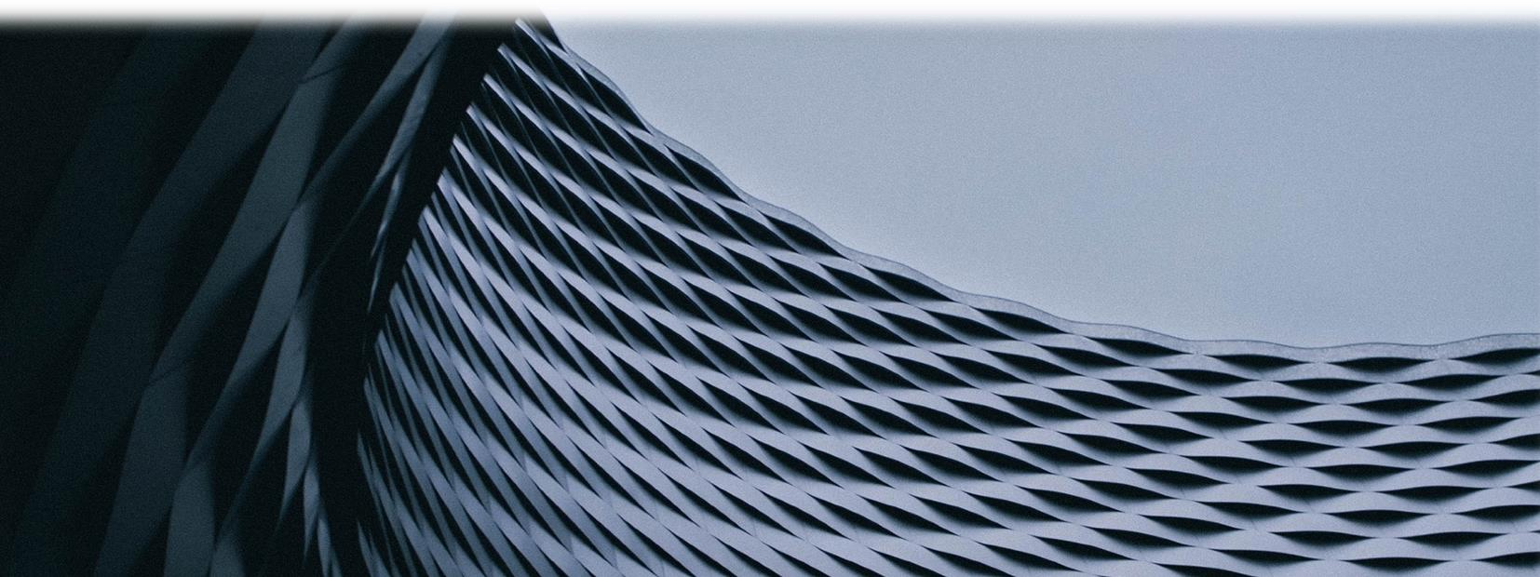
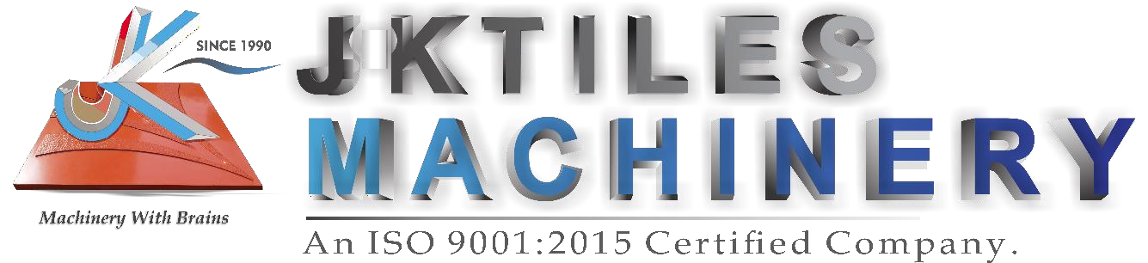

It All Starts With

THE ENDMOST CONCRETE PRODUCT SOLUTION




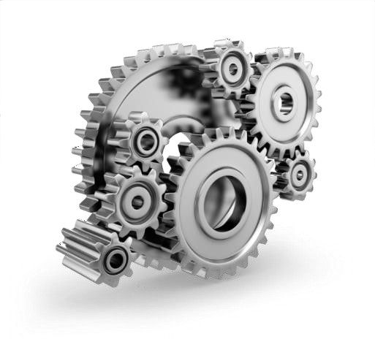



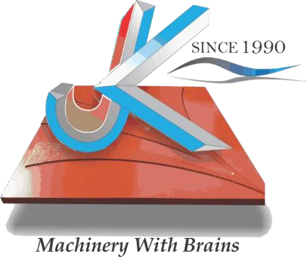
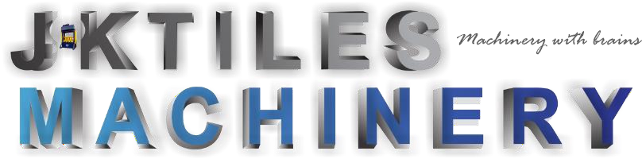


India’s Largest Chain of Machinery Manufacturing for making All types of Pavement Tiles, brick, CC Blocks in secondary industry Sector of manufacturing, Our national presence in 5 Major Indian States -
- Hyderabad, Telangana
- Guwahati, Assam.
- Noida, Uttar Pradesh
- Delhi NCR
- Bhubaneshwar, Odisha

P r o s p e c t u s O v e r v i e w

∇ Innovating Automation’s
∇ Endmost Concrete Product Solution
∇ Enthusiasm Customer Priority
∇ Incomparable product.

+91 9873997994
+91 9618440701


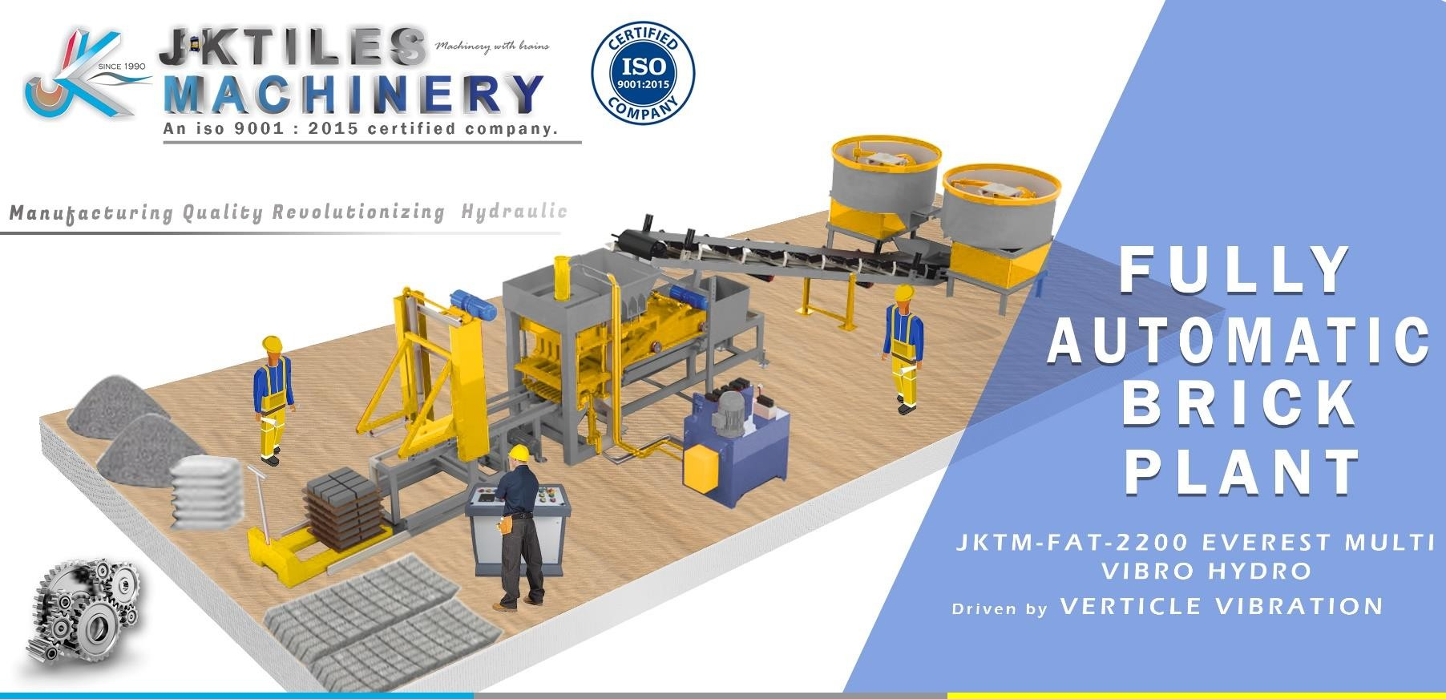


LEGENDER FAT- 2200 10CVT

Automatic Frequency Controlled VIBRO System With High Pressure.

Automatic Frequency Controlled VIBRO System With High Pressure.



Esteemed Machinery product partners

   | 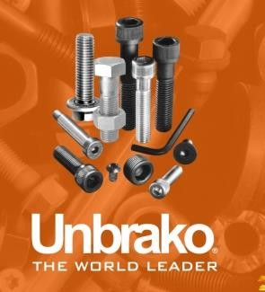 |  | 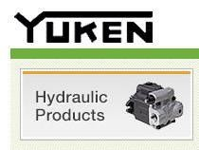
 |  |  | 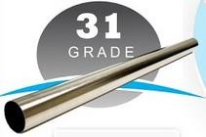

Note: All The Companies Given Above Are Only Our Manufacturing Partners, Which Provide Us All The Parts For The Manufacturing Of Machinery. These Includes Crompton™, Unbrako®, Dunlop™, Yuken®, Rexorth™, Schneider™, rajhans, ABB, etc.
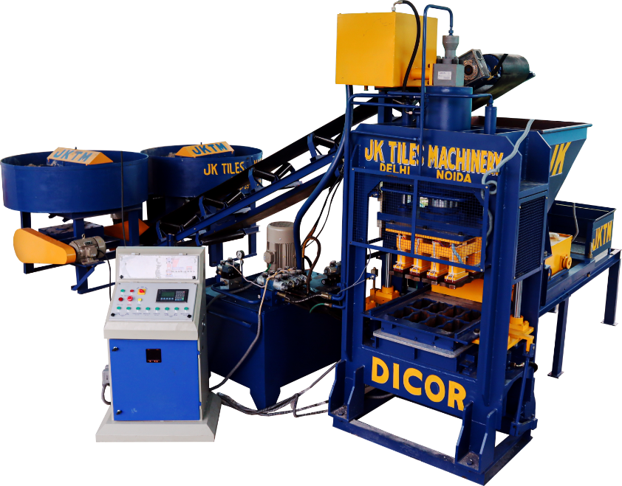

Machine Features JKTM-FAT-2200 LEGENDER
Fully Automatic Multi Hydro-Vibro
Multi Blocktech | Multi types of Brick & Block Manufacturing capacity.
Vibration Tech. | Vibro. compaction technology with Vibro. box & Two Motor for smooth vibration system
Double feeder | Main feeder for cement concrete material feeding & Other feeder for Color or Powder
Auto. Stacker | Automatic stacking system for finished goods output on Hydraulic lifting trolley.
Remote control | Inbuilt wifi system attachment for easy maintenance.
Chain system | Chain system in front of machine for speedy finished goods forwarding to stacking  system.
Double Pan Mixer | Double Pan mixer with 550kg. mixing capacity each for speedy & smooth material mixing.
Water adding syst. | Automatic water adding system with water pump & Timer.

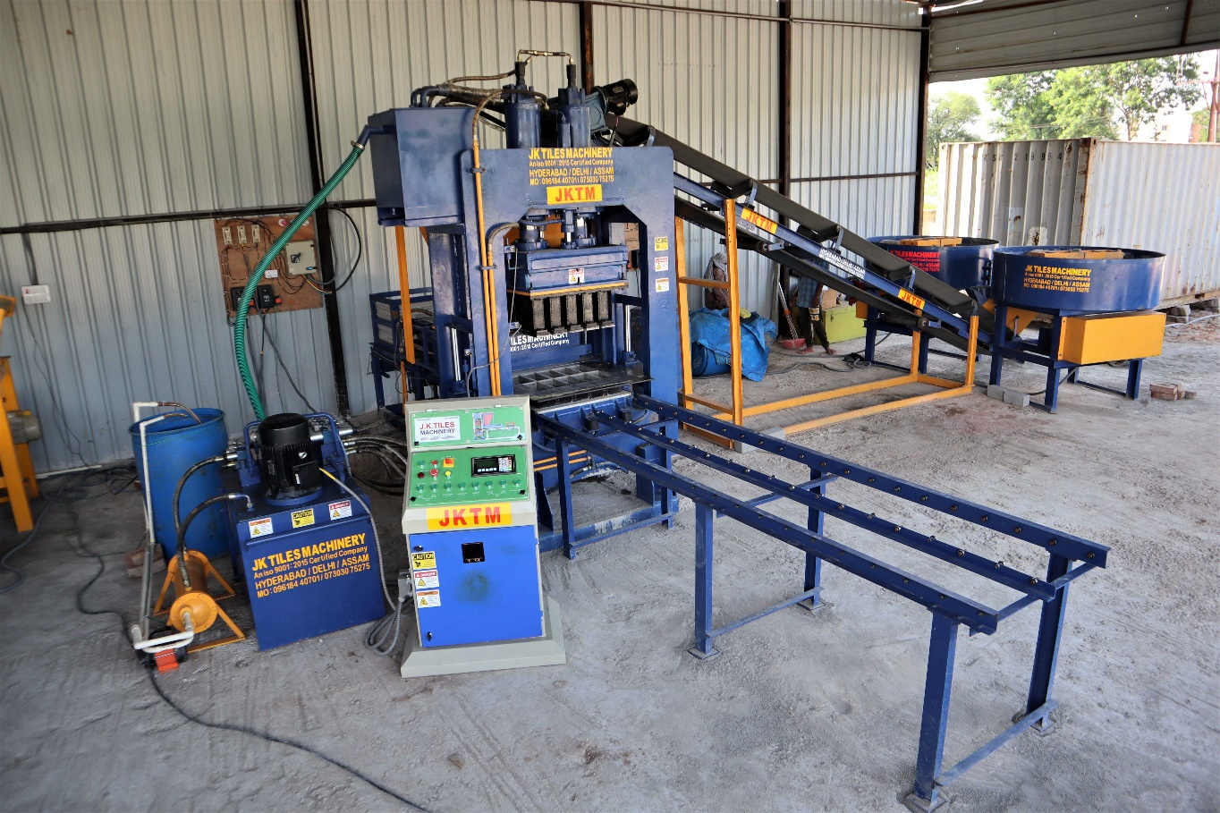

Output production images |  |  | Produce |  | L.  (mm) |  | W.  (mm) | H.  (mm) | Per stroke (3.5 stroke per minute) | Per Shift  (8-9 Hours production)
Bricks | 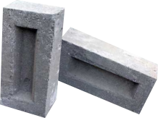 |  |  | Fly ash bricks | 225 |  | 100 | 75 | 10 cvt. | 19200-21600
Bricks |  |  |  | Cement bricks | 230 |  | 110 | 70 | 10 cvt. | 19200-21600
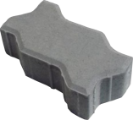  Paver block |  | 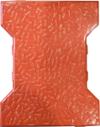 |  | Zig Zag paver | 225 | 112 |  | 60-100 | 8 cvt. | 15360-17280
 |  |  |  | I Shape paver | 200 | 165 |  | 60-100 | 6 cvt. | 11520-12960

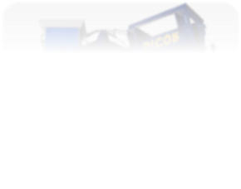
Machinery Parts Specification: JKTM-L-2500 LEGENDER
Multi Fully Automatic Hydro-Vibro
1. Main Machine & Technology
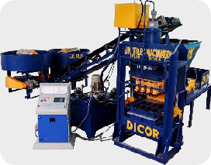 | : Heavy MS steel plate Body 22 to 25mm thickness, Hydraulic Main jack  & Two Side cylinder with Hydraulic oil seal Technoland / Rajhans.  : 240 to 260 Tones Pressure with Double Cylinder précised technology, Automatic Double Feeder facility, Sensor System Machine, Auto. Stacking system & Auto. PLC based Comp. Panel board system.
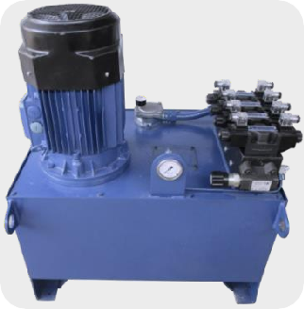 |  | 2.Power pack
: Hydraulic Pressure 250 Tonnage.
: 15 HP JKTM Motor (Own Brand) For Main
power pack with copper winding.

: 625 Liters Oil Tank with Oil Cooling System.
: Yuken® Plunger Pump.
: Pressure Meter Scientific/Micro.
: Sonoligh Control Valve Rexorth.
: Bosch Speed Gear Pump.
: Hydraulic Jack Oil Seal Technoland/ Ranjhans.

 |  | 3. Automation Wi fi PLC Panel Computerized Unit
: (EPCS)Electronic Pressure Control System.
: MS Steel Sensor System With Auto Stop Facility.
: (HSCS) Hydraulic Speed Control System.
: Electronics Parts By Siemens® & Delta.
: Dust & vermin proof Panel suitable for bottom cable entry.


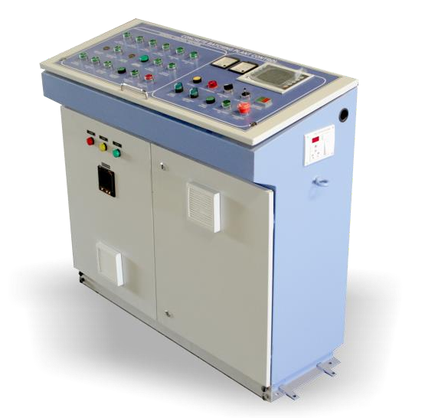
PLC Unit

For Fully Automatic multiple operations.

Other Important Features :- Electronics pressure control volume system. - MS steel sensor system with Auto stop facility. - Hydraulic speed control system & Vibrator control system. - Emergency Button, Stroke calculator, Delay Timer, LED & Display. - Facility to operate the machine in Automatic & Semi Auto. - Electronics parts Siemens, Schneider and Delta. - Panel is dust and vermin proof, suitable for bottom cable entry. - Each motor feeder have a MCCB(35KA) for overload and short circuit protection.




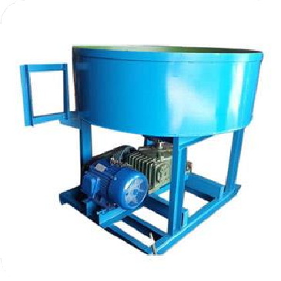

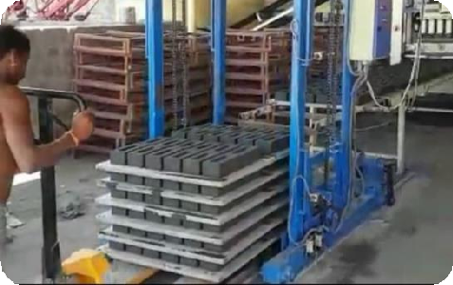

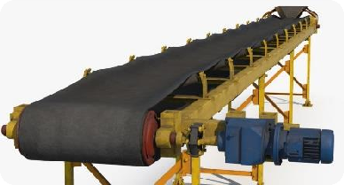
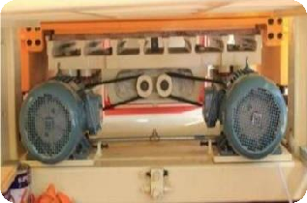
6.Auto Stacker System

- Automatic pallets stacking system for smooth & speedy operation.
- Power require 3 HP (1 Hp + 1 Hp + 1 Hp).
- Hydraulic Lifting system for running the stacker.
- Controlled by variable frequency drive
7. Color mixer Machine
- Capacity : 100 kgs to 125 kgs / Per Batch Power
(Motor): 2 Hp. – 1440 rpm Crompton/Havells Motor Manufacturing: Mixing of raw Materials of Top Layer Rubber Mould, Paver Block.

4.Conveyer belt System
Dimension(Belt) : 6850mm(20feet) X 500mm X 10mm motor : 2 HP
Gear Box : 3 liters
- To feed the mix from the pan mix to the Brick, Press: Capacity
2 Tons / hour Power (Motor) Bottom End 2 hp. 1440 RPM Crompton motor Storage intermittent Bin flow Regulation By heavy rollers Gear Box 300 - 30 *1 RPM
5.Double Cylinder Pressure Control System.

Introducing world’s First Double cylinder Hydraulic

technology to achieve -
- Best Strength and Designed Impression on Each piece.
- Précised Dimensional Accuracy.
- Uniform Size with Controlled Height.


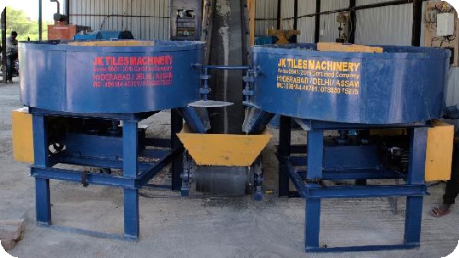

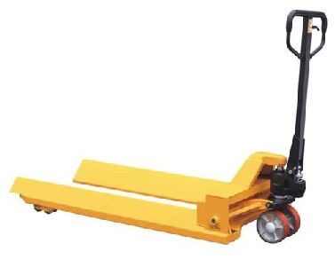
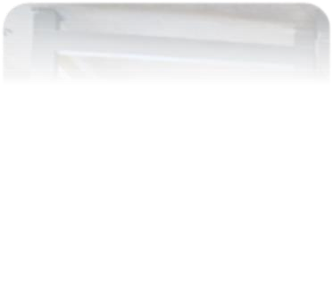
Hydraulic Trolley Manufactured using high-grade raw material, These Trucks are known for their high performance, Durability, strong construction and low maintenance. - Hand operated Hydraulic system.
8.Hydraulic Trolley

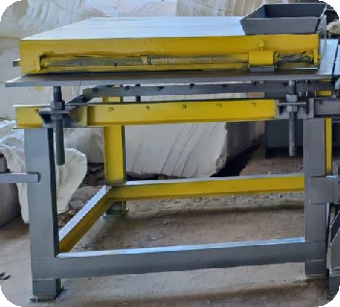 | 9.Color Feeder System(Optional)
fully automatic color secondary feeder system Attached with computerized plc panel to give efficient and
proper color input feeding.

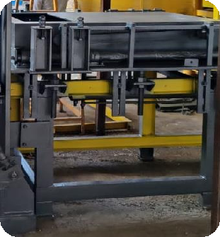 | 10.Concrete Main Feeder System
fully automatic concrete main feeder system
driven by twin directional motorized system
Attached with computersied plc panel to give
efficient and proper concrete inpur feeding.

11. Roller/Blade Pan mixer
  - 1500 mm diameter.

  - -10 to 12mm MS steel plate Circle & Side wall 4 + 4mm.
  - 500KGS. Raw materials mixing capacity.
  - Mixing by Rollers and Hand faced scrapers.

  - 7.5 HP + 7.5 Hp Crompton / Siemens / ABB / Havells motor.
  - Heavy body Gearbox, SKF(ISI)/NBC Bearing,
  - Discharge (Manual): Bottom door opening.
  - Material charge: Manual of conveyor











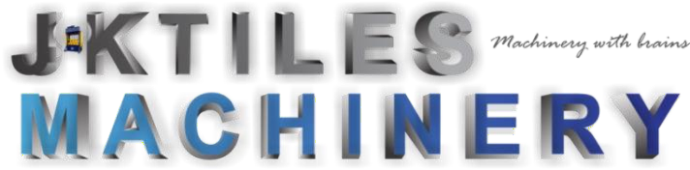
Address Line : NEAR PRADHAN MARKET , VILLAGE SARFABAD , SECTOR -73, NOIDA, Uttar Pradesh 201304
Quotation Date
Plant Type: Salesperson :
Payment Terms:

Client code :
JKNID1559864
CHEQUE.NEFT.DD
MR. FAIZ MALIK
JKTM-LEGENDER-2200
01-05-2023
Q U O T A T I O N
Company Add :
Quotation # 100011
E mail : Jktilesmachinery@gmail.com, jktilesmachinery1@gmail.com jktilesmachinery3@gmail.com
jktilesmachinery2@gmail.com,
Website : www.Jktilesmachinery.com, www.jktilesmachinery.co.in, /same.org Mob :+91 9873997994
+91 9618440701

Invoice And Shipping Address :

M/S Kanwar enterprises pvt. Ltd.

1x660 MW, sagardighi TPP, W. B
M A C H I N E R Y

S.no. | Description | Quantity | Unit price | Amount
1. | FULLY AUTOMATION 10 CVT BRICK MACHINE  Double Cylinder Pressure Control System.  - Model no JKTM L-2200 LEGENDER HYDRO VIBRO Brick And Paver Complete Machine.  - Vibro. compaction Technology, Automatic Single feeder.  - Pressure Control System :  vibro driven Hydraulic technology to achieve -  - Best Strength and Designed Impression on Each piece.  - Précised Dimensional Accuracy.  Uniform Size with Controlled | 1 Unit
2. | PAN MIXTURE  : Roller with Hand faced Blade Mixer 500kgs & Powerful warm reduction Gearbox Transmission for speedy & Smooth Mixing 7.5 HP + 7.5 HP | 2 Unit
3. | PLC WITH WIFI  FCCT FREQUENCY CONTROLLED TECH.  PLC Based Panel board system.  Computerized Panel Board System : Wecon / Schneider / Siemens Make Electronic Control System  With Remote Control features. | 1 SET
4. | JK Concrete Main Feeder Machinery System for Concrete Layer (Specs ref. above) | 1 SET
5. | POWER PACK  650 liters Hydraulic Oil tank with Oil cooling system.  Hydraulic Power-pack:15 Hp Crompton / Havells motor for smooth 270 Tons max hydraulic operation. | 1 SET
6. | BRICK DIE SET  : Brick Per stroke. 10pcs (Size L x W x H Resp. :225mm  x 100mm x 75mm) Attach in machine. 1 Nos. | 1 PCS
7. | Pallet feeder system with Automatic  Photosensitive Sensor gives empty pallet  alarm. | 1 SET

8. | Block Shifting Trolley. | 2 PCS
9. | Extra Necessary oil Seal Sets, 5 Extra Sensors. | 1 SET
10. | CONEYOR BELT  Dimension(Belt) : 7020mm X 450mm X 10mm  motor : 3 HP Gear Box : 3 liters | 1SET
 |  | TOTAL |  | ₹ 24,0,000/-
 |  | GST 18% |  | NIL
 |  | G TOTAL |  | ₹ 24,00,000/-
Note :
- Above Pricing Is EX-FACTORY & EXCLUDING GST And Tax (GST 18 % EXTRA on all above items.)
- Transportation to be borne by the client.
…



- Delivery time – 35-40 Days from the date of Advance Payment.
- 40% Payment as Advance at the time of placing order
- 60% Remaining payment at the time of delivery or before dispatch. (Then Only tax invoice will be generated)
- Any Amendments or Items Decrement in this quotation will lead to Regeneration of quotation.
- The Machinery Carries One (01) Year on Site warranty from the Date of Dispatch.
- Warranty on the Induction motors will be void if Proper Electrical fittings are not done as per our specification. (Fittings like proper Motor Starter along with Phase Preventers)
- All Transportation Extra To be borne by Client
- Quotation will be Revised or Amended if Any item in the quotation is Removed or added (in that case, discount will also be revised).
- Hydraulic Oil is not included with the machine, have to buy separately from the machine.
- Production of the machine varies on the practical field as compared to theoretical calculations written on the specification file.

Bank Name: - HDFC Bank. Branch Name: - Sector -71 Noida Account No: - 50200059599000 IFSC Code: - HDFC0009527


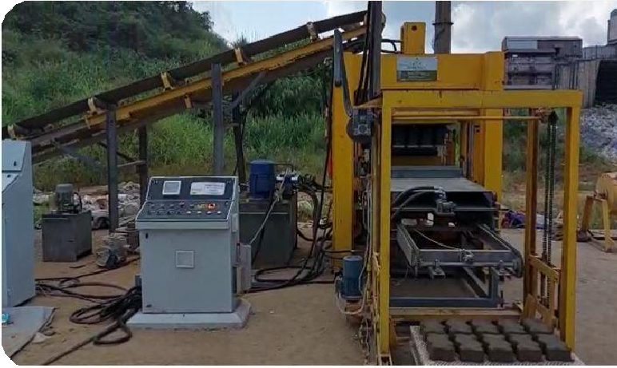


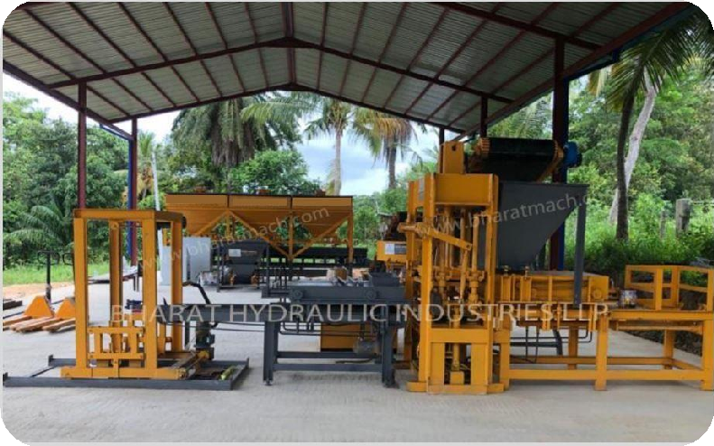


Actual Site Images
Electrical Requirements
Electricity Source Required (3 Phase 440 volts).

Total Machine Power load: 46 HP
Electric meter Required : 32.20
Total Machine Power load : 46 HP
Diesel Generator (D.G) Required : 65.40 (KVA)
1. Electricity (common) 2. Diesel Generator(D.G)

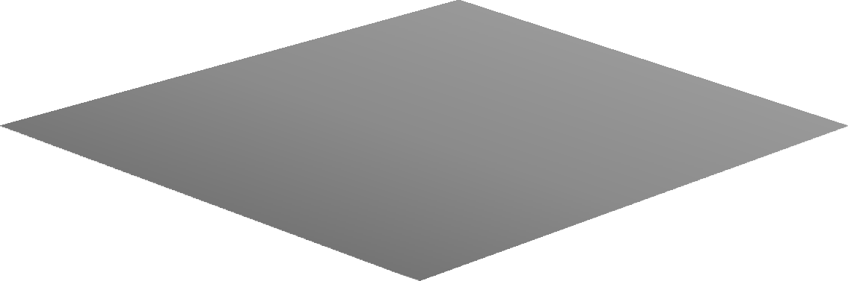















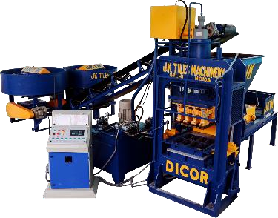

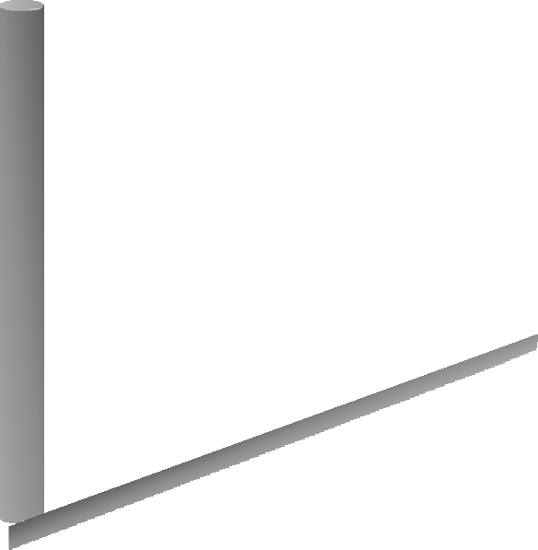



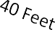
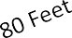

15 Feet

ConcreteBaseDimension ( LXBXH):- 40’ X60’ X5”





JKTM-FAT-2200
LEGENDER Fully Automatic Hydro – Vibro
1. Frequency Conversional Control Technology. The Automatic Block Making Machine utilize the frequency conversion Control technology, Keeping the precise and parallel movement between tamper and mould and avoiding its deformation. With the frequency Controlled vibration, the product gives proper control on the immediate start and half of the motors, preventing the motor from overheating caused by long term operation. As the vibration efficiency increases, The production rate will rise correspondently. There is 30% power saved by the product under the frequency conversional Control.
2. Double High Dynamic Directional Valves. This automatic block making machine utilizes double proportional and directional Valves with high activity to regulate the oil flow and pressure automatically, protecting the hydraulic cylinder from being damaged, which plays a buffer role in the process of production. And this kind of design of machinery can ensure the stable production and prolong the lifetime of machine
3. Wecon PLC Control System with Remote control feature. Electrical system machinery equipped is Wecon PLC control System, touch screen and electrical components. The control system is of Easy operation and low failure ratio. The machinery is equipped with data input and output device and data formula function. The visualized touch screen is characterized by simple operation. The Wecon PLC control system has logic control and If any small problem occurs, Problem will be displayed on the touch screen automatically. All electrical components like contractors, relays, switches even buttons on Control Panel are from Standard Makes Which give high performance and
4. Shaft Rotation & Compulsory Feeding The Automatic block making Machine is designed with the feeding device rotating at high speed. The raw can be blended evenly to make the blocks with optimal density and intensity.with uniform feeding the product is available in utilization different raw materials and moulds. The feeding frame bottom plate & mixing blades are made of high-duty HARDOX Steel, which strengthens the sealing performance and prevent the material leakage. The discharging gate is controlled by feeder reverse/forward system.
5. Heavy Duty Structure and wear resistance Moulds. Heavy duty structure and wear resistance moulds adopts CNC & Wire Cutting to Make sure paver size accuracy. Carbon-dioxide welding for crack resistance with heat treatment and carburization, sand blasting and other machining Process. It becomes more robust and resistant to the frequent & strong vibrations. The hardness reaches up to HRC52. In addition to heat treatment, we use stress relief process as another protection to the moulds and the other main parts of the machine.
6. High- Precision Guide Bearing & High Efficient Hydraulic System High-Precision guide bearings are used to assure the precise movement between the temper head and the mould. Heavy duty machine frame uses high- intensity steel and advanced heat treatment for making wear resistance. The Hydraulic pump & valve are from international brand. Adopt high-dynamic Proportional valve and constant output pump to adjust the oil speed & pressure, With the features of high-stability, high-efficiency and energy-saving





Our National Presence
in Four Major States.

ASSAM, GUWAHATI

Noida NCR ( HEAD OFFICE )

Bhubaneshwar (ODISHA)

HYDERABAD, TELANGANA

We Hope You Find Our Above Prospectus To Your Whole Satisfaction By All Terms, We Request You To Kindly Place Your Valuable Orders, Which Receive Our Best Attention And Promote Execution. Hope That We Can Establish A Good Business Relationship In The Nearest Future

Thanks.



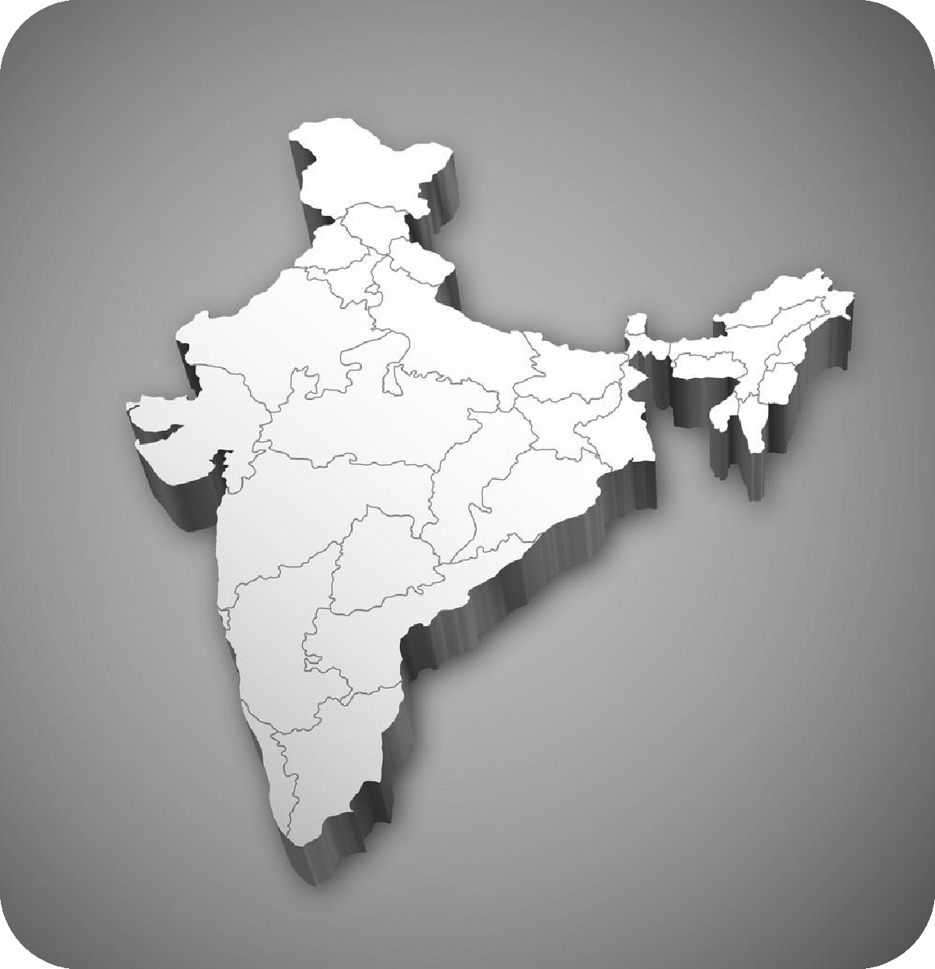


Mob :+91 9618440701
+91 9873997994

FB/page: JKTilesMachinery
Email : Jktilesmachinery@gmail.com Jktilesmachinery1@gmail.com Jktilesmachinery3@gmail.com
Web : Jktilesmachinery.com Jktilesmachinery.co.in





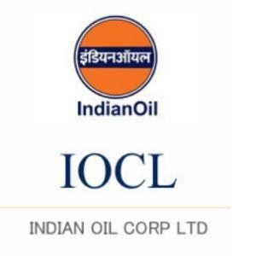
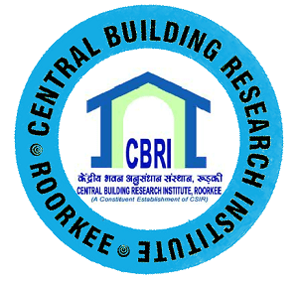
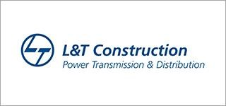

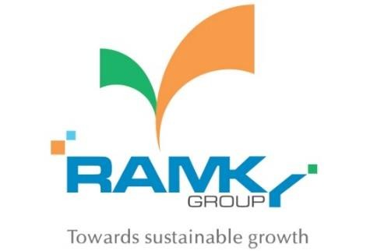


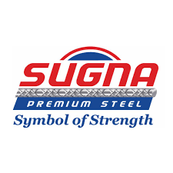

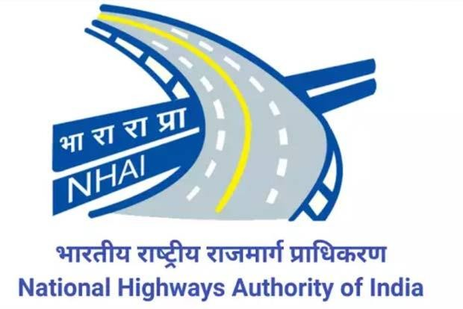


Mob :+91 9618440701
+91 9873997994

FB/page: JKTilesMachinery
Email : Jktilesmachinery3@gmail.com Jktilesmachinery@gmail.com Jktilesmachinery2@gmail.com
Websites: Jktilesmachinery.com Jktilesmachinery.org jktilesmachinery.in

